PEAK CLUSTER PIPELINE PROPOSALS

Crib Sheet
How to use this document
- Every factual statement carries a bracketed reference number, e.g. [1], matching the numbered source list on the final page.
- Where a figure is a claim made by the developer or another party, it is attributed as such (“Peak Cluster states…”, “Breedon's consultation states…”) rather than presented as an independent fact.
- This document is for information only. It is not legal, planning or financial advice; anyone affected by the proposals should take independent professional advice.
- The project is at the pre-application stage: route, dimensions and infrastructure are not yet fixed, and figures quoted are the maximums or estimates published to date.
A–Z of terms
Plain-English definitions of the terminology used in Peak Cluster's consultation material and in the planning process. The final column gives the source reference(s).
Term | What it means | Ref
AGI (Above Ground Installation) | A permanent, fenced surface facility on the pipeline route used to operate, monitor, inspect and maintain the pipeline. Peak Cluster's consultation material describes a series of AGIs along the route, including 'feeder' and 'connection' AGIs (e.g. a North Feeder AGI south of Chapel-en-le-Frith and a Central Feeder AGI south-west of Macclesfield). | [1, 12]
BVS (Block Valve Station) | A smaller installation containing valves that let the operator remotely monitor the pipeline and shut off ('isolate') sections of it, for maintenance or to limit the amount of CO₂ released in the event of an emergency. Peak Cluster states the number and locations of BVSs will be confirmed at a later stage. | [1]
Calcination | The chemical step at the heart of cement and lime making: limestone (calcium carbonate) is heated to convert it into calcium oxide, releasing CO₂. Peak Cluster states this process chemistry cannot be changed, which is why it argues carbon capture is the only way to cut these 'process emissions'. | [2]
CCS (Carbon Capture and Storage) | Technology that captures CO₂ at the point it is produced, compresses it, transports it (here, by pipeline) and injects it into geological formations for permanent storage. Peak Cluster states CCS can capture up to 95% of the CO₂ from industrial processes. | [2]
Coastal AGI | The largest proposed installation: a compressor station near the north of the Wirral peninsula where CO₂ would be compressed, metered and monitored before being sent offshore. Peak Cluster states it would need a maximum site area of around 300 m × 180 m (excluding access), operate continuously with a small number of staff, and include a compressor, associated equipment and a chimney or vent stack. Two search areas are being considered: a 'landfall zone' and an 'inland zone'. | [1]
Compulsory acquisition | Powers, granted through a DCO, that allow a developer to acquire land or rights over land (such as easements) without the owner's agreement, with compensation. Rural professional advisers have warned landowners along the route to understand their compensation and negotiation rights. | [9, 13]
Construction corridor / working width | The temporary strip of land needed while the pipeline is built — for the trench, soil storage, vehicles and equipment. Public reporting describes a working corridor of around 30 metres during construction, within a much wider 'scoping corridor' shown on early plans (reported at up to 300 m wide, expected to narrow as the design develops). | [3, 4]
DCO (Development Consent Order) | The single legal consent required for a Nationally Significant Infrastructure Project under the Planning Act 2008. It is granted (or refused) by the Secretary of State, not local councils, and can include compulsory acquisition powers. The Planning Inspectorate lists Peak Cluster's DCO application as expected to be submitted in September 2027. | [5, 6]
DESNZ / Secretary of State | The Department for Energy Security and Net Zero. Because Peak Cluster is an NSIP, the final decision on the DCO rests with the Secretary of State for Energy Security and Net Zero. | [6]
Easement | A permanent legal right over someone else's land — here, the right to lay, keep and access a pipeline beneath it. Land above the pipe is intended to be restored and farmed again, subject to restrictions in the easement. | [9]
EIA (Environmental Impact Assessment) | The formal assessment of a project's likely significant environmental effects, during construction and operation, which must accompany the DCO application. Arup has been appointed to lead the EIA and DCO work for Peak Cluster, supported by AECOM and Quod. | [7]
HDD (Horizontal Directional Drilling) | A 'trenchless' construction technique that drills the pipeline underneath obstacles - rivers, major roads, sensitive habitats - without opening the surface. Reported as the method to be used where open trenching is unsuitable. | [3]
Landfall | The point where the onshore pipeline meets the sea and transitions to the offshore pipeline(s) - proposed at the northern end of the Wirral peninsula. | [1, 6]
Limestone (calcium carbonate) | The raw material for both cement and lime, quarried at each of the plants in the scheme. The Derbyshire/Staffordshire deposits are Carboniferous limestone of unusually high purity. | [2, 8]
MNZ (Morecambe Net Zero) | Spirit Energy's proposed CO₂ storage project: depleted natural gas reservoirs beneath the East Irish Sea (Morecambe Bay) would be repurposed to store CO₂ permanently. MNZ is a separate but linked project — Peak Cluster delivers the CO₂ to it. | [2, 7]
NSIP (Nationally Significant Infrastructure Project) | A category of large infrastructure project defined by the Planning Act 2008. NSIP status means the project bypasses the normal local planning system and is consented through the DCO process instead. Peak Cluster has this status because of its scale. | [5, 10]
National Wealth Fund | The UK Government's investment body. It has invested £28.6 million in Peak Cluster, which the project states unlocked £31 million from private partners. | [11]
Open trench (open cut) | The standard construction method for most of the route: excavate a trench, lay the pipe, backfill with the original soil, and reinstate the surface. | [3]
PCL (Peak Cluster Limited) | The special purpose joint venture company funding development of the onshore pipeline. Its shareholders are the cement and lime operators (Breedon, Tarmac, Holcim and Buxton Lime), developer Progressive Energy, Summit Energy Evolution Limited (a subsidiary of Sumitomo Corporation) and the UK National Wealth Fund. | [1]
PINS (Planning Inspectorate) | The government agency that administers the DCO process: it examines the application at a public examination and recommends a decision to the Secretary of State. Members of the public register as 'Interested Parties' to take part once an application is accepted. | [6]
Pre-application | The current stage of the project (as listed by the Planning Inspectorate): the developer consults, surveys and designs before formally submitting the DCO application. Statutory consultation is a legal requirement of this stage. | [6, 10]
Progressive Energy | The low-carbon energy project developer leading development of Peak Cluster on behalf of the partners. | [1]
ROMP (Review of Old Mineral Permissions) | A statutory review (under the Environment Act 1995) of the planning conditions attached to older quarry permissions, carried out periodically. ROMP documents are a key public source for quarry end-dates and reserves. | [8]
Spirit Energy | The UK energy company that would operate the Morecambe Net Zero CO₂ store that Peak Cluster's pipeline feeds. | [2, 11]
Vent stack | A chimney-like structure used to release gas in controlled circumstances (e.g. maintenance or emergency depressurisation). Peak Cluster states the Coastal AGI would include a chimney or vent stack; campaign analysis of the consultation factsheet reports a stack of up to 50 m in height may be required, with most other structures up to 15 m high. | [1, 12]

The plants: who is involved, what they produce, and how long the limestone lasts
Plant | Operator | Location | What it produces · permissions, reserves & closure information (publicly reported)
Tunstead cement plant | Tarmac | Tunstead, near Buxton, Derbyshire (Great Rocks Dale) | Produces cement, construction aggregates and industrial limestone powders; one of the largest cement facilities in Europe, fed by the UK's largest limestone quarry (c. 5–6 million tonnes extracted per year, capped at 10 Mt/yr combined with Old Moor). The operator considers combined reserves sufficient for over 30 years. Planning permissions: Tunstead expires 22 February 2042; Old Moor expires 30 January 2040. [8, 14, 15]
Tunstead lime works | Buxton Lime (Lhoist group) | Tunstead, near Buxton, Derbyshire | The lime plant at Tunstead is described as the largest in Britain, producing quicklime (calcium oxide) and lime products for steel, water treatment, chemicals, construction and agriculture. It shares the Tunstead quarry complex and its permission timescales above. [15]
Hope Cement Works | Breedon | Hope Valley, Derbyshire (Peak District National Park) | Produces cement (reported emissions of almost 1.2 Mt CO₂ in 2019, the largest local source). The works' permission runs to 22 February 2042, and Breedon's own consultation states that at current extraction rates the limestone quarry may be exhausted by the mid-2030s. Breedon has applied to extract a further 13 million tonnes of limestone to extend quarrying by about 7.5 years, to February 2042, protecting 223+ on-site jobs. Breedon has separately consulted on the future of the site after 2042, when quarrying is expected to end; under the 1969 consent, permanent cessation triggers decommissioning and restoration of the works. [16, 17, 18, 19]
Cauldon cement plant | Holcim (formerly Aggregate Industries / Lafarge) | Cauldon, Staffordshire Moorlands | Produces cement from the adjacent Cauldon quarry complex. A planning application (ref. SCC/22/0136/FULL-ES) seeks consolidation of permissions, extensions of the limestone and shale quarries and an extension of time for working remaining reserves; Staffordshire County Council's planning committee was due to consider a report on it at its 2 October 2025 meeting. [20]

Note on project membership: when the scheme was first announced in 2023 it was described as five cement and lime plants (including Lhoist's Hindlow lime works) plus the Lostock Sustainable Energy Plant in Northwich. The project's current material describes four plants: Tunstead (cement), Tunstead (lime), Hope and Cauldon. ^{[1, 21]}
Note on 'closure' dates: no operator has announced a closure. The dates above are the expiry dates of the existing mineral planning permissions and the operators' own published estimates of when reserves could be exhausted, both of which can change through the planning system (as the Hope and Cauldon extension applications show). Quarry permissions across the Peak District planning area commonly expire in 2042, a legacy of permissions granted in February 1982. ^{[8, 17, 18, 20, 22]}

Item | Publicly reported figure
Onshore pipeline length | Reported at approximately 198 km from the Derbyshire/Staffordshire plants to the north of the Wirral (media reports have also described it as '121 miles' / 'more than 100 miles'). [3, 4]
Offshore pipeline length | Around 90 km including the section from landfall, per Peak Cluster; route work is ongoing. [1]
Onshore pipe diameter | Up to 91.4 cm (36 inches); Peak Cluster has also described an anticipated range of 24–36 inches. [1]
Offshore pipe diameter | Up to two buried offshore pipelines, each up to 1.1 m (42 inches) in diameter, from the Coastal AGI to mean low water springs. [1]
Burial depth | Reported as at least four feet (approx. 1.2 m) underground. [4]
Construction working corridor | Around 30 m wide during construction; the early 'scoping corridor' shown on plans is reported at up to 300 m wide, expected to narrow to around 100 m before final route selection. [3, 4]
Coastal AGI site area | Up to around 300 m × 180 m (5.4 ha), excluding access - with a compressor, equipment and a chimney/vent stack; two candidate zones on the north Wirral. [1]
Above Ground Installations | Public reporting describes five AGIs along the onshore route; consultation mapping names feeder and connection AGIs (e.g. south of Chapel-en-le-Frith, south-west of Macclesfield, north-west of Holmes Chapel), plus the Coastal AGI. [3, 12]
CO₂ captured | Over 3 million tonnes per year once operational - stated by the project to be almost a quarter of Staffordshire and Derbyshire's annual emissions. [1]
Investment | £28.6 m from the National Wealth Fund, stated to have unlocked £31 m from private partners; MNZ and Peak Cluster together are stated to represent £5 bn of capital investment. [11]
Jobs | The project states it will safeguard and create more than 13,000 jobs (with MNZ) by 2050, with c. 1,500 construction jobs across the East Midlands and North West. [1, 13]
Timeline | Pre-application stage now; DCO application expected September 2027 (Planning Inspectorate); the project has publicly targeted being operational around 2030 / 'from the next decade'. [6, 11, 21]

Visual guide to scale

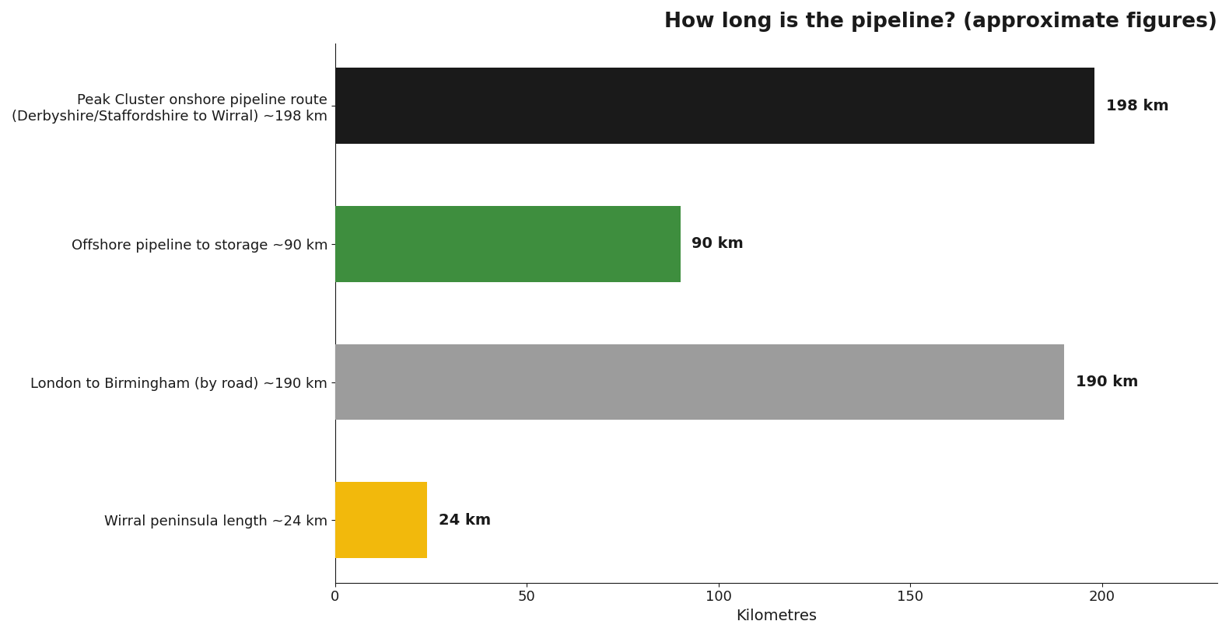
Figure 1 - Approximate route lengths compared with familiar distances. Sources [1, 3]
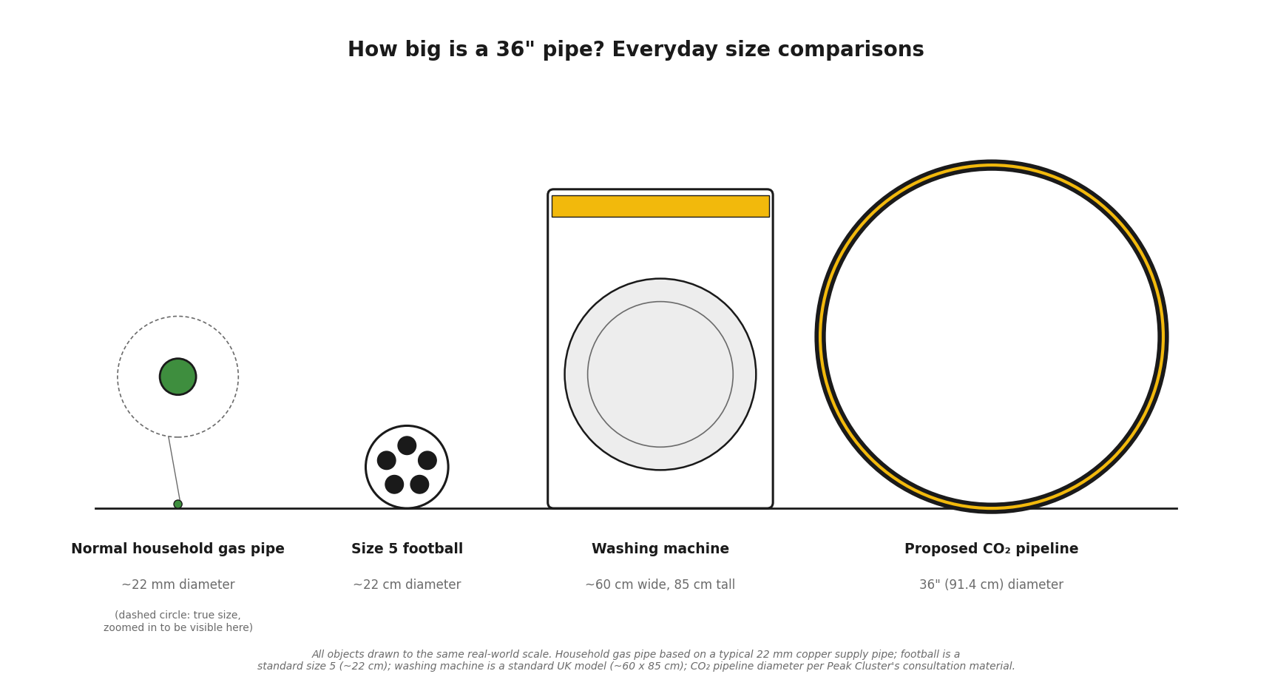

Figure 2 - Pipe diameters compared with everyday relatable objects, drawn to the same scale. Sources [1].

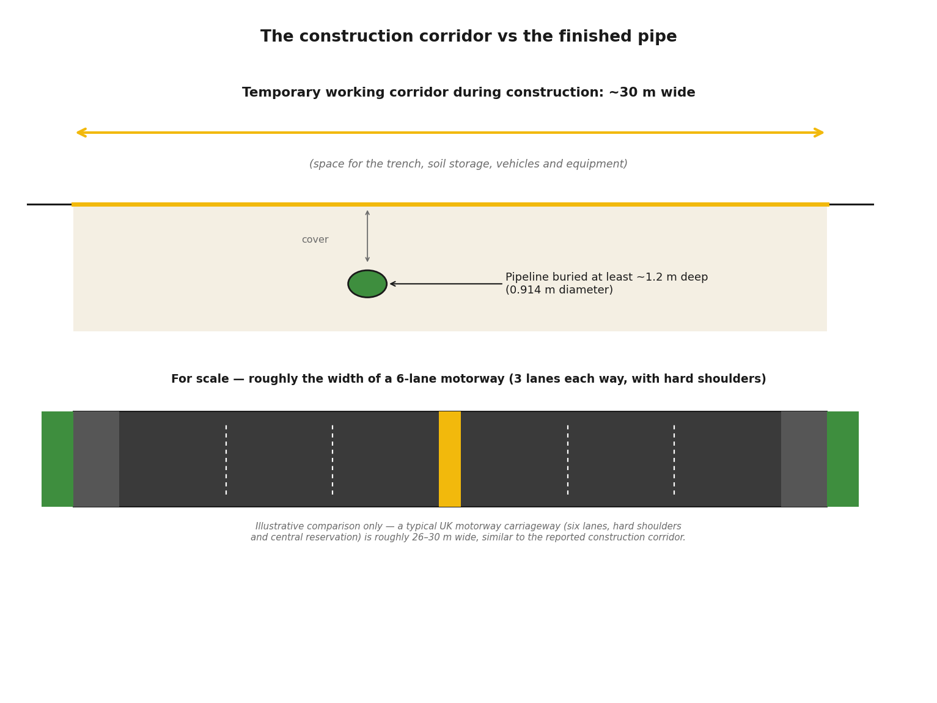Figure 3 - The ~30 m temporary working corridor compared with the finished buried pipe. Sources [3, 4].
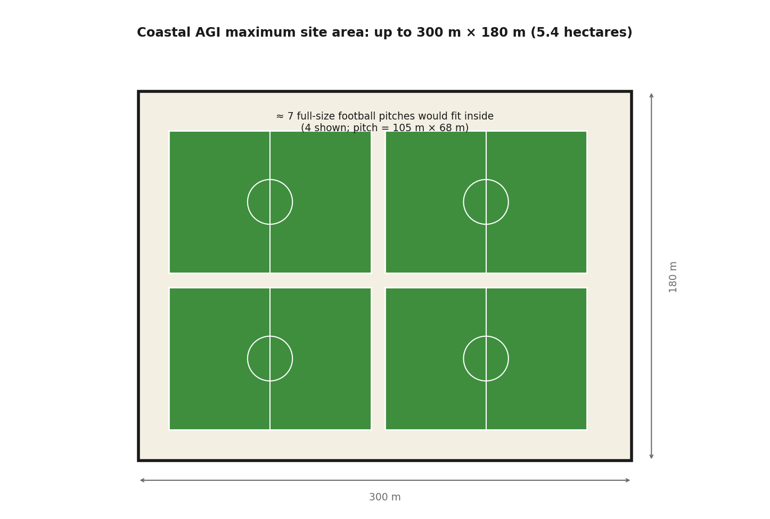
Figure 4 - Maximum published footprint of the Coastal AGI, with full-size football pitches for scale. Sources [1].

The consenting process in five steps

- Pre-application (now): the developer consults communities and statutory bodies, carries out surveys and environmental assessment, and refines the design. The project is at this stage, with public consultation having taken place in 2026. ^{[6, 10]}
- Submission & acceptance: the DCO application is submitted to the Planning Inspectorate (expected September 2027); PINS has 28 days to decide whether to accept it for examination. ^{[6]}
- Registration: once accepted, members of the public and organisations can register as Interested Parties to make representations and view all application documents. ^{[6]}
- Examination: an Examining Authority appointed by PINS tests the application through written representations and hearings, normally over six months. ^{[6]}
- Recommendation & decision: PINS recommends; the Secretary of State for Energy Security and Net Zero decides whether to grant the DCO, which can include compulsory acquisition powers. ^{[5, 6]}

Sources (all publicly available; accessed August 2026)

[1] Peak Cluster — 'Your Questions Answered' (project FAQ): peakcluster.co.uk/your-questions-answered
[2] Peak Cluster — 'Carbon Capture and Storage' project page: peakcluster.co.uk/carbon-capture-and-storage
[3] Selby Rural / land agent briefing — 'Peak Cluster: what do you need to know?' (Nov 2025): selbyrural.co.uk/peak-cluster-what-you-need-to-know
[4] ITV News (9 Mar 2026) 'Hundreds of Wirral residents protest against Peak Cluster pipeline'; GB News (Apr 2026) reporting on pipeline dimensions and corridor: itv.com/news/granada; gbnews.com
[5] CPRE Peak District & South Yorkshire — 'Understanding the Peak Cluster Project' (Jan 2026): cprepdsy.org.uk/news/understanding-the-peak-cluster-project
[6] Planning Inspectorate — Peak Cluster CCS Pipeline project page (ref. EN0710001), national-infrastructure-consenting.planninginspectorate.gov.uk/projects/EN0710001
[7] Arup — 'Arup appointed to the world's largest cement and lime decarbonisation project' (Oct 2025): arup.com
[8] Derbyshire County Council / Peak District NPA — Tunstead & Old Moor ROMP report (NP/HPK/1013/0898): democracy.peakdistrict.gov.uk (permission end dates, extraction rates, reserves)
[9] Butcher & Barlow LLP — 'Peak Cluster CO₂ pipeline: what farmers and landowners need to know' (Dec 2025): butcher-barlow.co.uk
[10] High Peak Borough Council — 'Peak Cluster – Carbon Capture Pipeline Project' (Nov 2025): highpeak.gov.uk/article/8494

[11] Peak Cluster news pages (Jan 2026): peakcluster.co.uk/2026/01 (National Wealth Fund investment, MNZ, 3 Mt/yr, 40% of UK cement & lime)
[12] Peak Cluster consultation website — route section mapping and AGI naming: peakcluster-consultation.co.uk; Action Against CCS — 'AGIs, Block Valve Stations and Peak Cluster' analysis of consultation factsheets: actionagainstccs.com/agi
[13] Derbyshire Times (Jan 2026) — 'Derbyshire farmers and residents consider carbon capture underground pipeline plan': derbyshiretimes.co.uk
[14] Gosselin Mining — Tunstead Limestone Quarry overview: gosselinmining.com (site scale, 5–6 Mt/yr, largest UK limestone quarry)
[15] Cement Kilns UK — Tunstead history and lime plant: cementkilns.co.uk/cement_kiln_tunstead.html
[16] Hope Valley Climate Action — response to Breedon planning application NP/HPK/1020/0929 (1.2 Mt CO₂ in 2019; permission to 2042): hopevalleyclimateaction.org.uk
[17] Breedon 'Hope Extension and Solar' public consultation (Deetu/Engaged Space): my.engaged.space/hope (mid-2030s exhaustion; extension need)
[18] Derbyshire Times (Feb 2026) & Global Cement (Mar 2026) — Hope Works quarry extension application: 13 Mt limestone, +7.5 years to Feb 2042, 223 jobs: derbyshiretimes.co.uk; globalcement.com
[19] Peak District NPA planning committee report (Aug 2022), application NP/HPK/1020/0929 — Hope Works ARM rail importation; cessation by 22 Feb 2042 and decommissioning/restoration obligations under the 1969 consent: democracy.peakdistrict.gov.uk
[20] Staffordshire County Council — 'Applications making headlines': Cauldon Quarry Complex application SCC/22/0136/FULL-ES: staffordshire.gov.uk/planning
[21] East Midlands Combined County Authority — Mayor's visit to Peak Cluster ('fully up and running in 2030'): eastmidlands-cca.gov.uk; BBC News (May

2023) 'Pipeline network planned to cut greenhouse gas emissions from industry'
[22] Derbyshire and Derby Minerals Local Plan — Chapter 7.2 Industrial Limestone Development Paper: derbyshire.gov.uk (more than 40 active or dormant mineral sites in the plan area have permissions expiring in 2042, stemming from permissions granted in February 1982)

Disclaimer: This document summarises information published by the project developer, public authorities, professional advisers, community organisations and news media, with each statement attributed to its source. It is provided for general information and does not constitute legal or professional advice. Figures reflect the position at the date of preparation and are subject to change as the project develops. Any views quoted are those of the attributed source.

